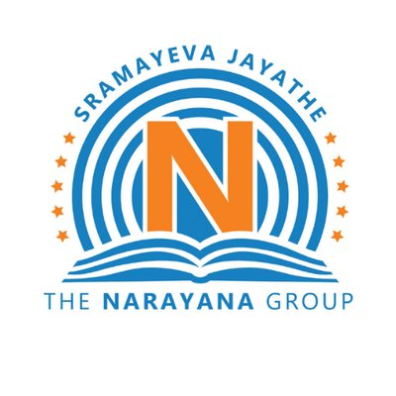

Session 2020-21

Central Board Of Secondary Education

Computer Science Project On
Banking Management

Prepared By:
Amogh Krishna
Kushal Sena

Certified that the Project Report Entitled
Banking Management

Is bonafied work carried out by Amogh Krishna And Kushal Sena in Fulfillment prescribed by the CENTRAL BOARD OF SECONDARY EDUCATION for CBSE+2 COMPUTER SCIENCE during the academic year 2020-2021. The project report has been approved as it satisfies the academic requirements in respect of Project prescribed for CBSE+2.

……………………… ………………………
Mrs. Gayatri G Anantha Rao
Respected Teacher Respected Principal

Externals Signature: 1)………………………

2)………………………

